**ECM Korean Deals Manual**

1. Go to DART site: <http://dart.fss.or.kr/dsab002/main.do> click on the tabs below

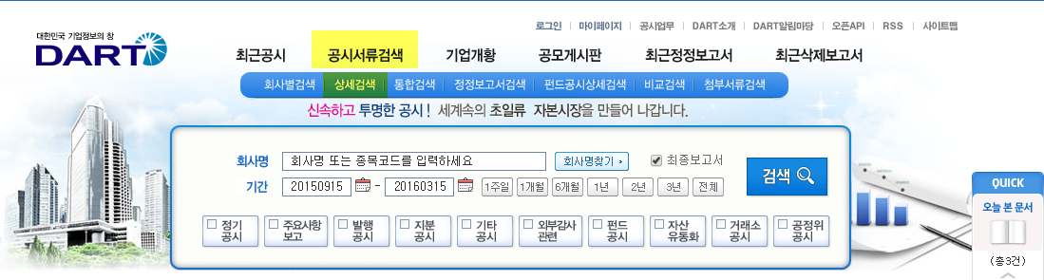

1. Check the boxes below – Securities report (equities) for IPO and FO, Securities report (debt) for Equity-linked transactions

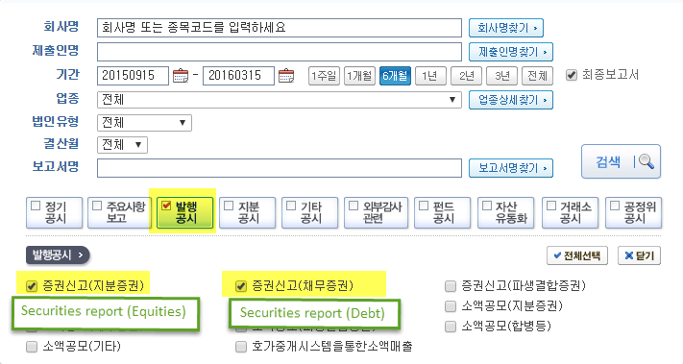

1. Look/search for key words:
   * Prospectus -투자설명서
   * Securities Report - 증권신고서(지분증권)
2. **For the most up-to-date information of the deal, look for [정정후] (after revision)**

ECM entry system

1. **IPO**
2. Company: Click the upper left corner to find out the issuer’s English name.
   1.  Olive Green – Unlisted company
   2.  Orange – Korea Composite Stock Price Index (KOSPI) = Main Board
   3.  Purple – KOSDAQ Composite Index (KOSDAQ)
   4.  Sky Blue – Korea New Exchange (KONEX)
3. Announcement/Filing Date
   1. Use the earliest date available in the list

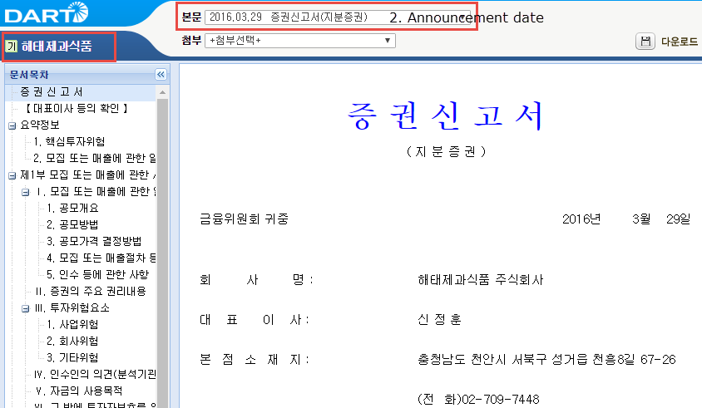

Example used: 해태제과식품(주) Haitai Confectionery & Foods Co Ltd

1. Expected Date

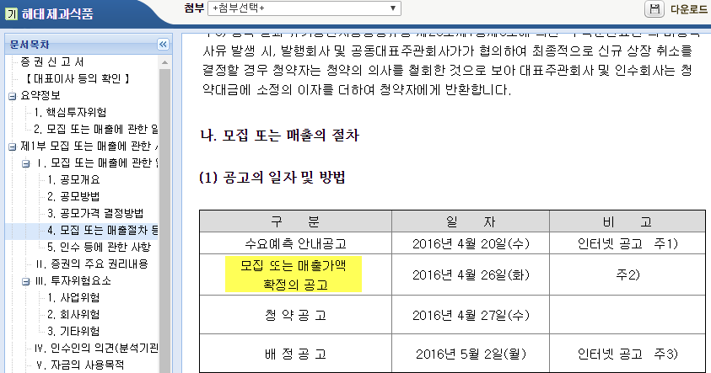

1. Subscription start/end
2. Settlement  
   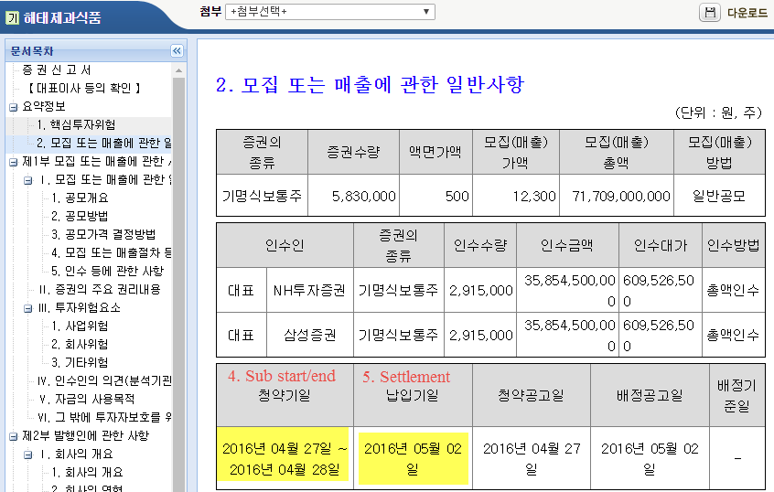
3. First Trade Date
   1. Announced on the settlement date
4. New shares (신주모집) and/or Secondary shares (구주매출)
   1. **일반공모** - General Public (Institutional + Retail)
   2. **우리사주조합** – Employees
   3. **일반청약자** – Retail portion
   4. **기관투자자** – Institutional portion

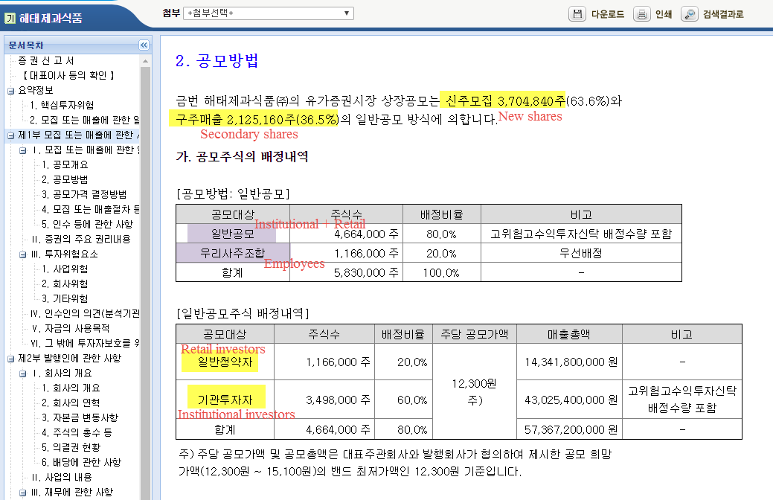

1. Outstanding shares/ Pre-deal number of shares – go to**주식의 총수**section

k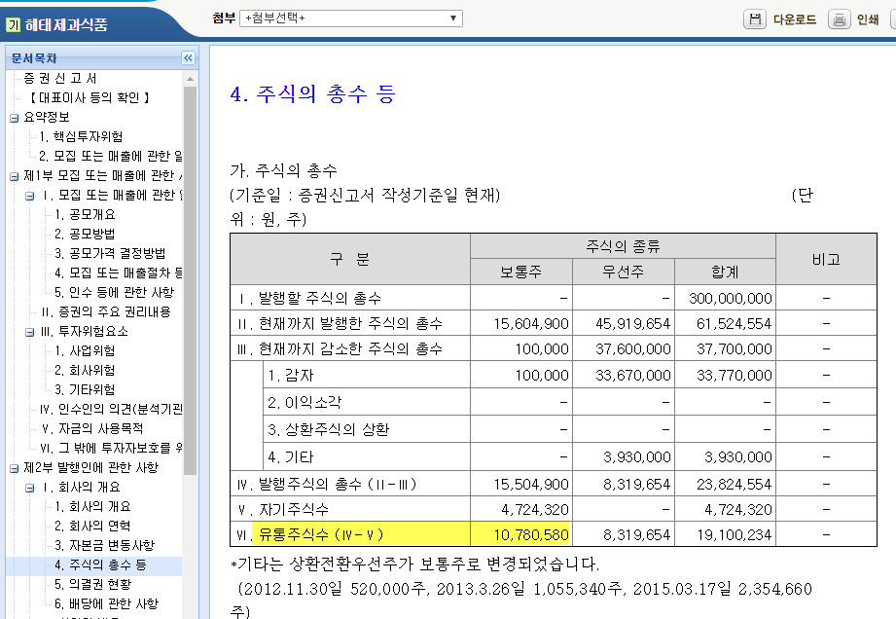

1. Use of proceeds – go to **자금의 사용목적** or **자금의 사용계획**section

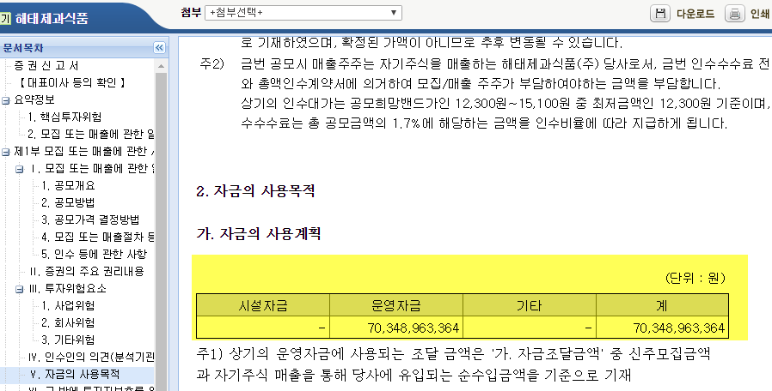

**운영자금** (General corporate purpose); **시설자금** (Expansion); **차환**or**상환** (Repay debt); **타법인주식획득** (Acquisition)

Selling shareholder: check out 매출인 or 매출대상주식의 소유자 section (e.g. #440131)

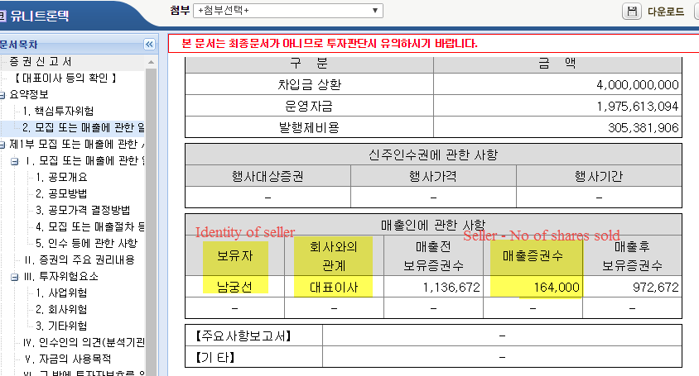

or

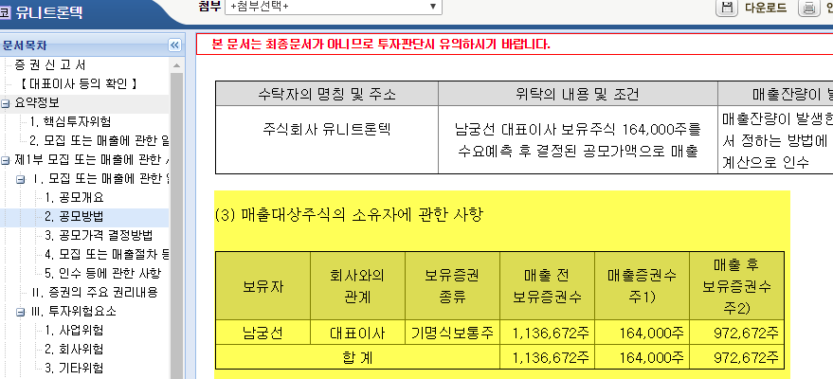

1. Tranche level information

* Tranche Sub-Type: IPO-OP
* Share Description: Ordinary Shares
* Target Market: KOF (Korea)
* Security Type: CSO (common stock/ordinary shares)
* Retail/Institutional: R,I
* Bearer/Registered: R
* Currency: KRW
* Listings (Exchange)
  1. Korea Stock Exchange 🡪 KO (유가증권시장)
  2. KOSDAQ 🡪 KQ (코스닥시장)

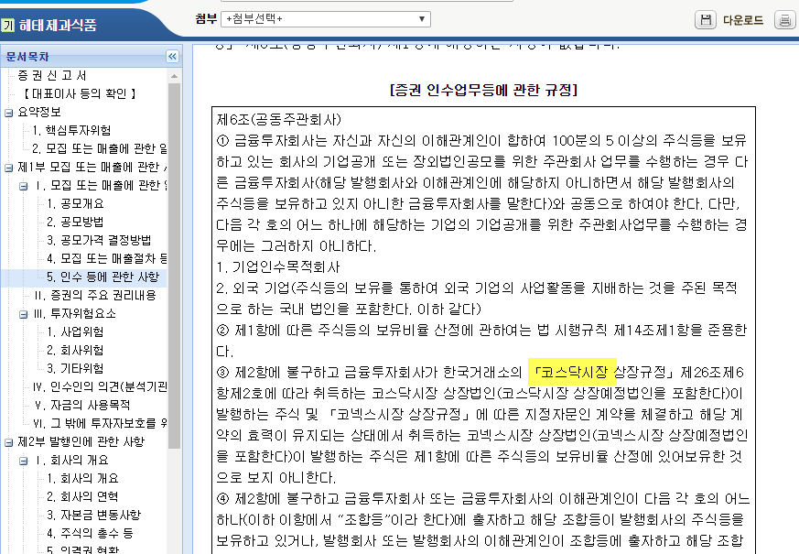

* Ticker – will be available after listing

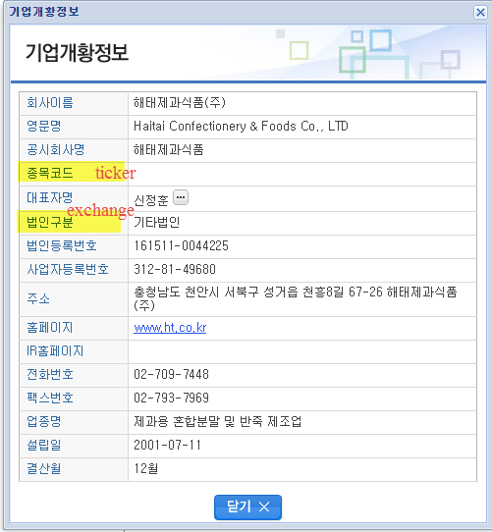

* Shares/Price range/Banks/ Fees/Participation

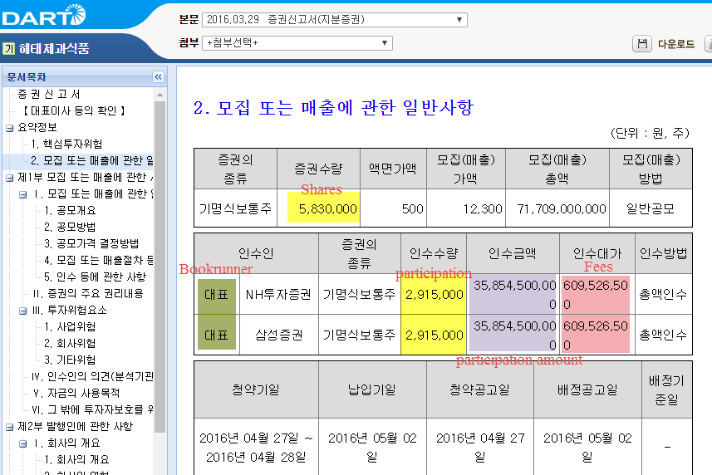

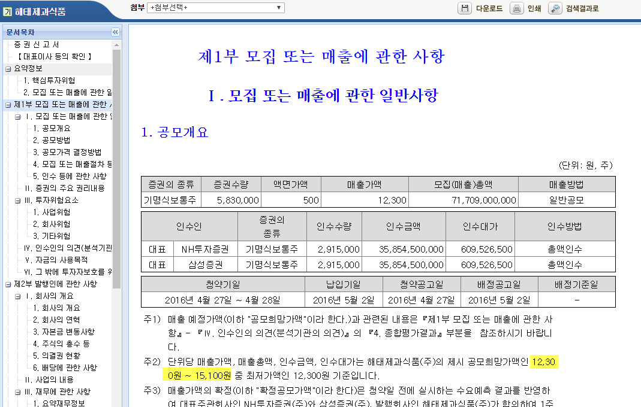

* Participation (detailed version) (e.g. #437896)
  1. 대표주관회사 🡪 lead bookrunner
  2. 공동주관회사 🡪 co-bookrunner = lead manager?
  3. 인수회사 🡪 co-manager

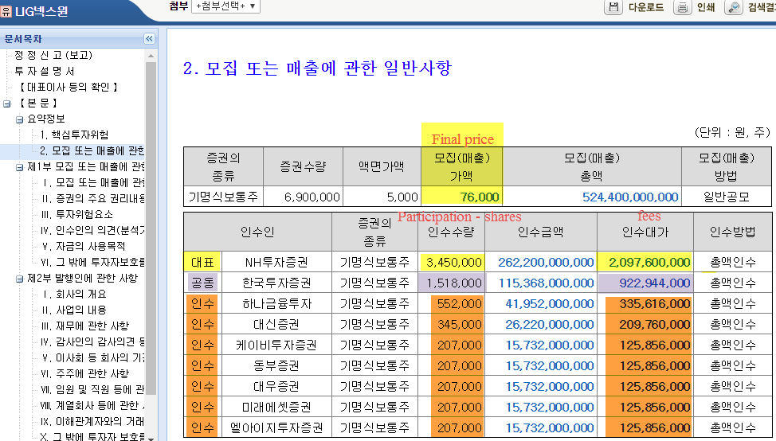

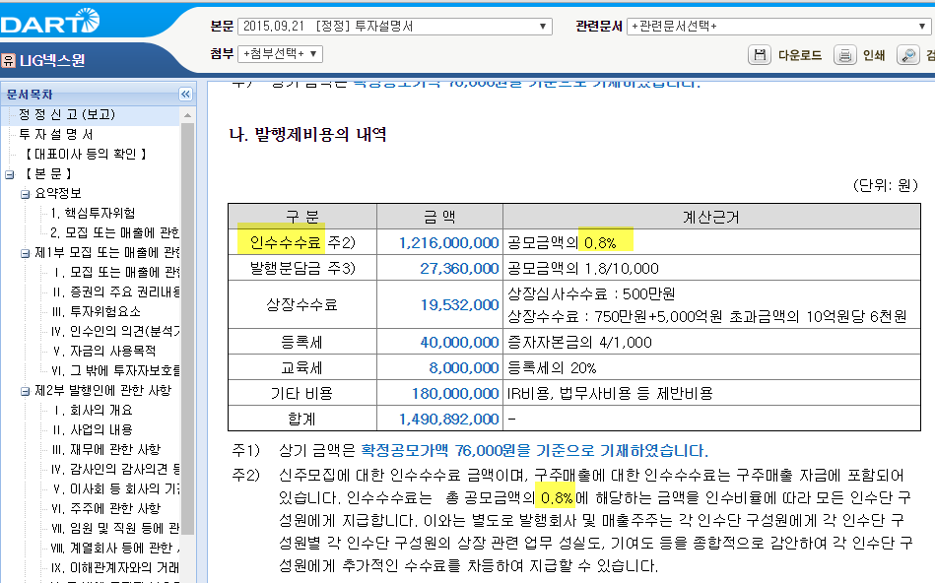

1. **Rights Issue**

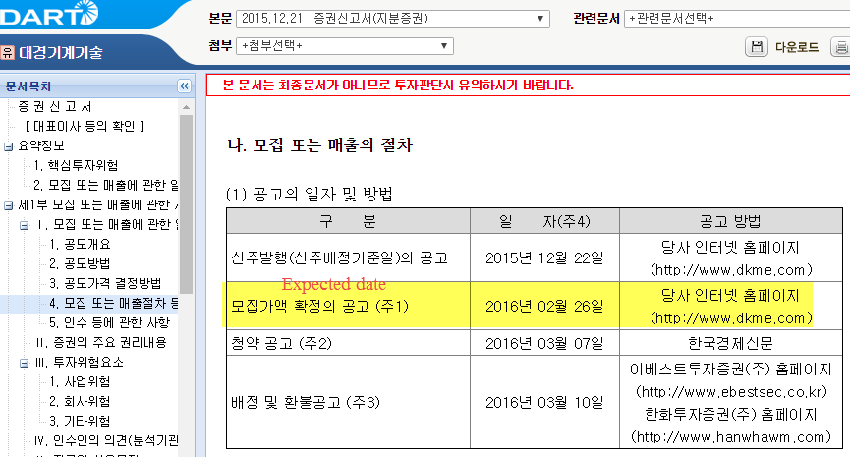

Example used: 대경기계기술 Daekyung Machinery & Engineering Co Ltd (#440992)

1. Expected date (모집가액 확정의 공고)
2. Rights Ratio

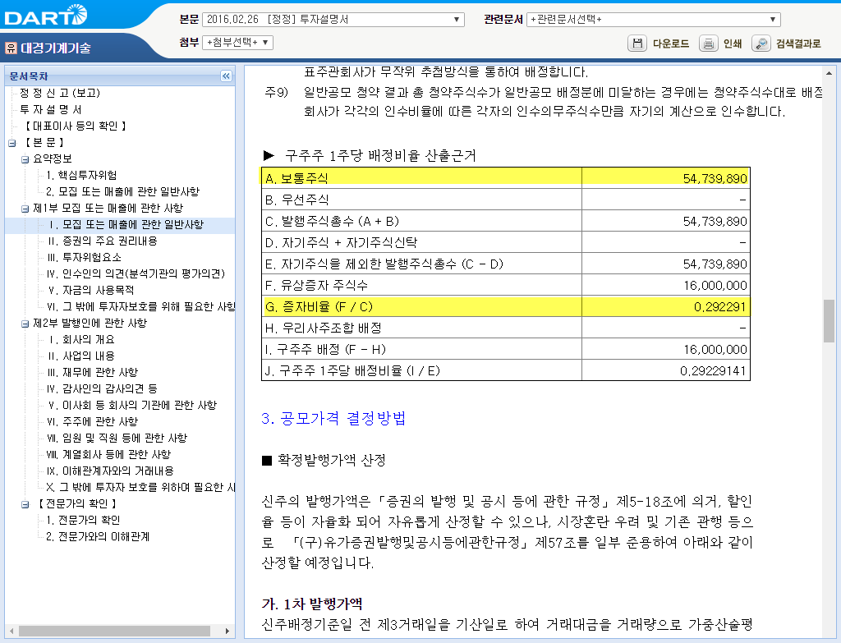

* Rights ratio = F (유상증자 주식수)/A (보통주식) = Shares Offered/ Shares Outstanding
  + And then normalize to 1

1. Subscription rate/ level note – check 유상증자또는주식관련사채등의청약결과(자율공시) or normal one (증권발행실적보고서) to calculate

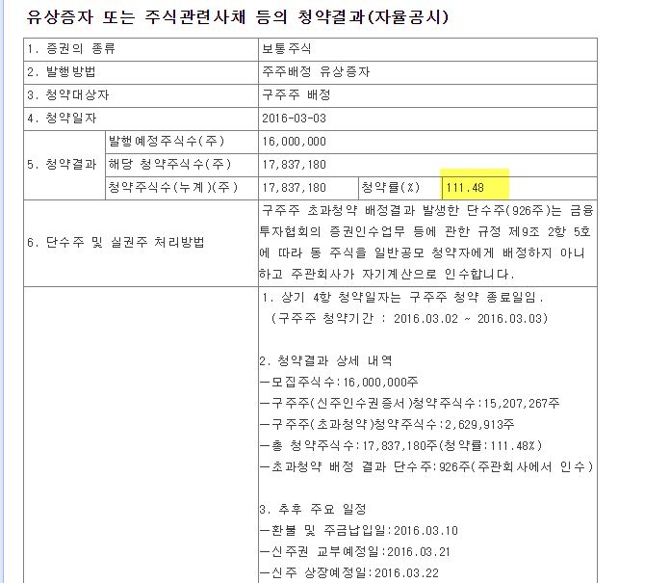

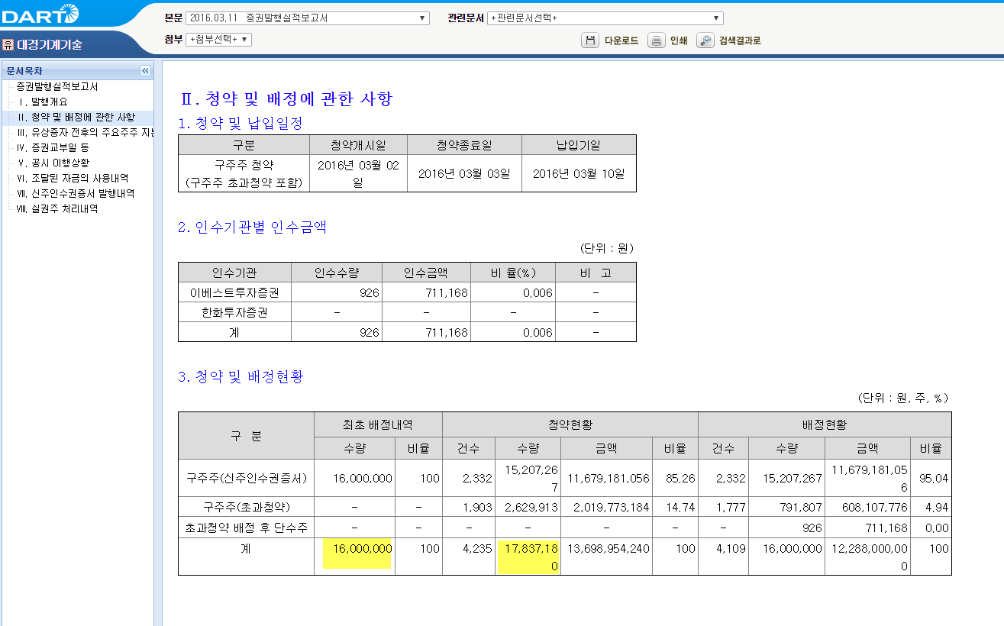

1. Fees/Participation

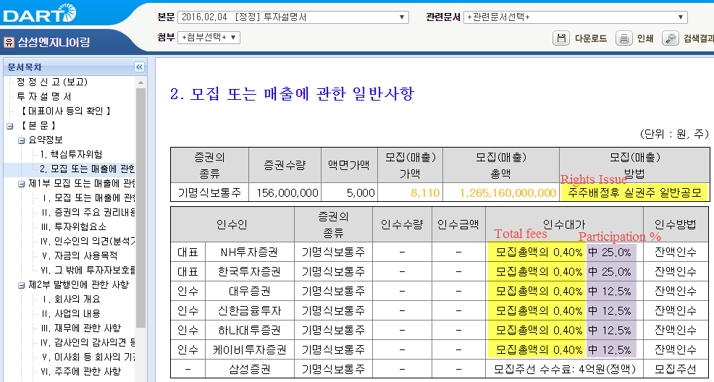

[ Bonds with Warrants ] (신주인수권부사채)

[http://dart.fss.or.kr/dsaf001/main.do?rcpNo=20160114000044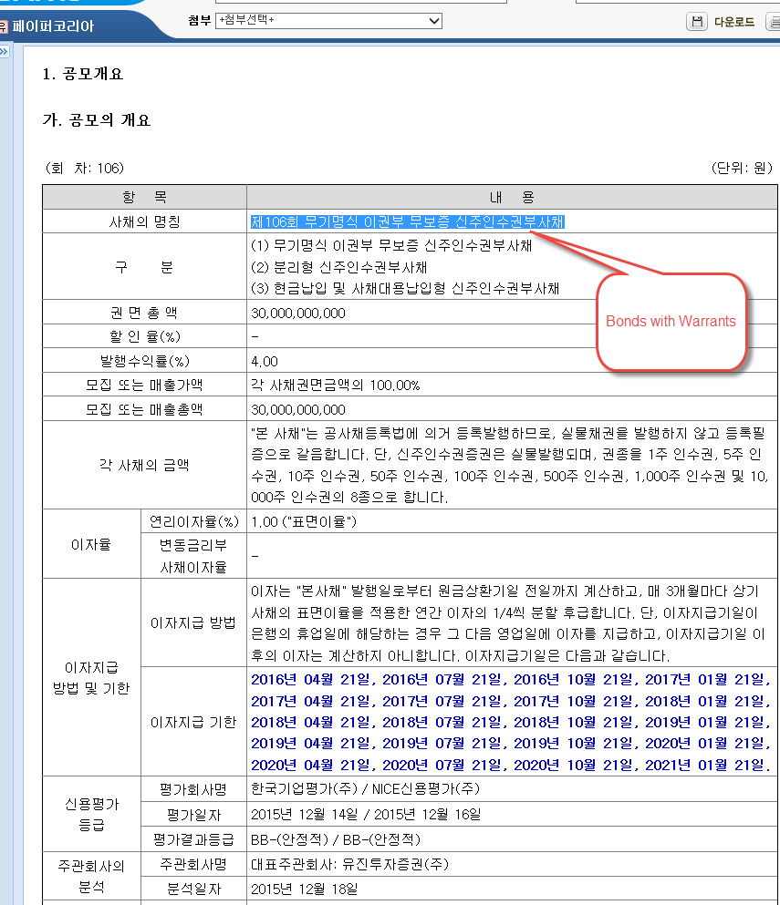](http://dart.fss.or.kr/dsaf001/main.do?rcpNo=20160114000044)

[Convertible Bond] - 전환사채

